Thesis - Draft #1

Visualizing and Solving Organic Chemistry Reactions Using Augmented Reality

Name

College

HON-490: Honors Thesis

Professor

4/10/2025

# Abstract

Organic chemistry is a challenging subject due to the complexity of reaction mechanisms and the spatial reasoning required to understand molecular interactions. Traditional learning methods, such as two-dimensional textbook diagrams, often fail to convey the three-dimensional nature of chemical structures. This research explores the use of augmented reality to improve the visualization and understanding of organic chemistry reactions. By combining optical character recognition with graph-based molecular modeling, the system detects and interprets line-angle reaction diagrams, applies rule-based transformations, and renders the resulting product molecule in three dimensions using augmented reality. The project also investigates the limitations of existing OCR tools in recognizing chemical symbols and considers the potential of machine learning models for handling handwritten notation. By bridging traditional diagram-based inputs with immersive 3D outputs, this work presents a novel, offline-compatible approach to learning and exploring organic reaction mechanisms.

*Keywords:* augmented reality, organic chemistry, molecular visualization, OCR, mobile chemistry education

# Visualizing and Solving Organic Chemistry Reactions Using Augmented Reality

Organic chemistry is often challenging for students, especially when trying to visualize reaction mechanisms and molecular structures. This difficulty stems from the subject’s inherently three-dimensional nature, which is typically taught through two-dimensional diagrams in textbooks and on screens. As a result, many learners struggle to understand how atoms and bonds interact in space.

Augmented reality (AR) offers a promising solution by allowing students to engage with molecules in an interactive, spatial format. In chemistry education, AR has been shown to improve both comprehension and engagement by making abstract concepts more tangible through 3D visualization.

This thesis presents the design of a mobile application that uses AR to help students visualize the products of organic reactions. The system analyzes images of typed line-angle skeletal structures using computer vision and graph theory, simulates the corresponding reaction, and renders the resulting molecule in augmented reality. It addresses the question: *How can augmented reality be used in software to visualize and solve organic chemistry reactions?*

# Literature Review

Augmented reality (AR) has become a valuable tool in chemistry education, particularly for helping students visualize molecular structures in three dimensions. Research consistently shows that AR can improve spatial reasoning and engagement by allowing learners to interact with digital models.

Levy et al. (2024) introduced MoleculAR, a mobile app that helped students better understand molecular geometry by viewing structures in 3D. Eriksen et al. (2020) found similar benefits, showing that students gained a stronger grasp of bonding and structure by manipulating ball-and-stick models in real time. Midak et al. (2022) applied AR at the secondary level using physical materials paired with a mobile app to teach carbohydrates. Their results showed higher engagement and retention compared to traditional methods. Aw et al. (2020) developed an offline-capable AR app for exploring complex molecular structures, highlighting the value of intuitive touch interaction for learning.

While these tools enhance visualization, they do not simulate reaction outcomes. This thesis builds on prior work by introducing a mobile application that interprets typed skeletal diagrams, simulates simple organic reactions, and visualizes the resulting product molecules in AR. In doing so, it extends the role of AR from visualization to problem solving in organic chemistry education.

# Methodology

This project involves developing an offline Android application that uses augmented reality to help students visualize the products of organic chemistry reactions. The app integrates multiple technologies to process input images, interpret molecular structures, simulate reactions, and render 3D AR models.

The process begins with the user uploading or capturing an image of a typed line-angle skeletal structure. OpenCV is used to preprocess the image by converting it to grayscale, binarizing it, and detecting contours to isolate lines and text regions. Google ML Kit performs optical character recognition (OCR) to detect atomic symbols. To reduce errors, the app includes logic to distinguish between multi-letter symbols (e.g., “Zn”) and separate one-letter atoms (e.g., “O” and “H” in “OH”).

Using this data, the molecule is modeled as an undirected multigraph with atoms as nodes and bonds as edges, based on spatial relationships. A rule-based engine then modifies the graph to reflect the chosen reaction type.

Next, the Chemistry Development Kit (CDK) generates 3D coordinates for the updated structure. The final molecule is rendered in real-time using SceneView and ARCore, anchored to a physical surface via the device’s camera. This interactive visualization helps students better understand molecular structure and reaction outcomes.

**Figure 1**

*Backend pipeline for the ARChemistry application*

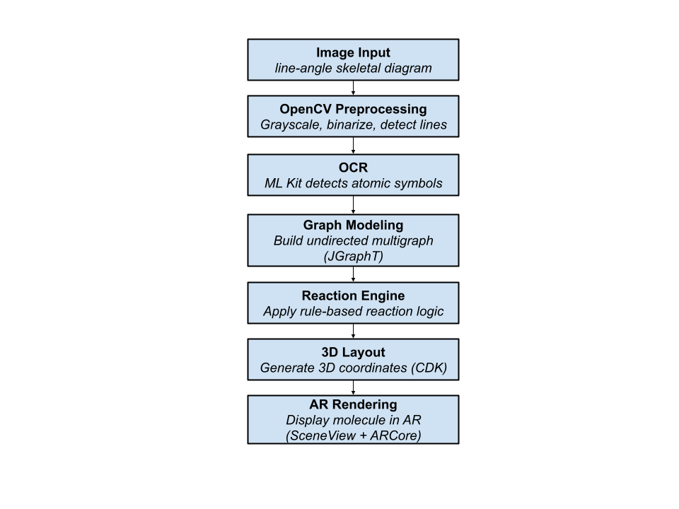

# System Architecture

The ARChemistry application is built around four main components: the image processor, OCR engine, molecule modeler, and AR renderer. These modules work together to convert a 2D skeletal reaction diagram into a fully rendered 3D molecule in augmented reality.

The image processor uses OpenCV to convert the input to grayscale, apply thresholding, and detect contours. This prepares the image for reliable text extraction and bond recognition.

The OCR engine, powered by Google ML Kit, identifies atomic symbols in the image. It distinguishes between single-letter and multi-letter atoms (such as O and Cl) and records their coordinates for graph modeling.

The molecule modeler builds an undirected multigraph using JGraphT, where atoms are nodes and bonds are edges inferred from spatial relationships. A rule-based engine updates the graph to reflect the selected reaction, and CDK is used to generate 3D coordinates.

Finally, the AR renderer uses ARCore and SceneView to display the molecule in real space. It anchors the model to a physical surface, allowing users to interact with and explore the structure in augmented reality.

# Results

Development of the ARChemistry application is ongoing. The system architecture has been fully planned, with modules defined for image preprocessing, OCR, graph construction, reaction simulation, and augmented reality rendering. So far, development has focused on the user interface and testing image selection and cropping features for typed inputs.

Although the complete backend pipeline is not yet connected, initial tests of individual components have shown promising results. OpenCV preprocessing successfully isolates line angle structures, and Google ML Kit is able to detect typed atomic symbols with reasonable accuracy under controlled conditions.

The minimum viable product will support hydrogenation, halogenation, and dihydroxylation reactions, selected for their clear structural changes and educational value. As development progresses, the goal is to demonstrate a complete workflow that transforms an input image into an interactive augmented reality visualization of the product molecule.

# Obstacles and Workarounds

Developing the ARChemistry application has come with several technical challenges. One major issue is detecting chemical symbols in typed skeletal structures. Characters often overlap with molecular lines, making text recognition unreliable. To improve accuracy, OpenCV preprocessing is used to separate potential text regions before applying Google ML Kit.

Another challenge is telling the difference between multi-letter symbols, like Cl or Zn, and separate one-letter atoms such as O and H. This is handled by grouping nearby characters and checking them against a list of valid chemical elements.

Bond detection is also complex. Because the input is an image rather than structured data, the system must estimate bonds based on the spacing and position of atoms. These geometric rules are still being fine-tuned to avoid errors in interpretation.

Rendering the final molecule in three dimensions required additional adjustments. The Chemistry Development Kit relies on the Abstract Window Toolkit, which is not compatible with Android. To address this, the app uses only the parts of CDK that do not depend on AWT, and simpler calculations are done manually when needed.

Each part of the system is tested separately to keep performance smooth and the structure flexible. Ongoing workarounds focus on improving accuracy while keeping the software lightweight and functional without needing an internet connection.

# Future Work

Several features are planned to expand the ARChemistry application beyond its initial version. Future development will include connecting all core components to complete the full process from image input to augmented reality visualization of the product molecule. More reaction types will be supported, moving beyond basic examples like hydrogenation, halogenation, and dihydroxylation to include more complex transformations.

To improve accuracy and visual clarity, the app will support wedge and dash notation for stereochemistry. A custom machine learning model may also be trained to recognize handwritten symbols, allowing the system to process non typed inputs more reliably. Interactive features, such as rotating or zooming molecules through touch gestures, may also be added to enhance the user experience.

Once a working version is complete, the app will be tested with students and instructors to gather feedback on usability, educational value, and overall performance. These insights will guide future improvements to both the features and the learning experience the app provides.

# Conclusion

This project shows how augmented reality can support the learning of organic chemistry by turning static diagrams into interactive three-dimensional models. By combining computer vision, OCR, graph theory, and AR rendering, the ARChemistry application introduces a new and accessible way to visualize reaction outcomes more intuitively.

Although still in progress, this project creates a strong foundation for future chemistry tools that connect traditional diagram based learning with spatial, hands on exploration. Planned features like support for more reaction types, stereochemistry, and handwritten input will strengthen its educational value. Once complete, the app is designed to serve as a useful offline tool for both students and instructors, making complex reactions easier to understand and more engaging to explore.

# References

Aw, J. K., Boellaard, K. C., Tan, T. K., Yap, J., Loh, Y. P., Colasson, B., Blanc, É., Lam, Y., & Fung, F. M. (2020). Interacting with three-dimensional molecular structures using an augmented reality mobile app. *Journal of Chemical Education, 97*(10), 3877–3881. <https://doi.org/10.1021/acs.jchemed.0c00387>

Eriksen, K., Nielsen, B. E., & Pittelkow, M. (2020). Visualizing 3D molecular structures using an augmented reality app. *Journal of Chemical Education, 97*(4), 108–111.https://doi.org/10.1021/acs.jchemed.9b01033

Levy, J., Chagunda, I. C., Iosub, V., Leitch, D. C., & McIndoe, J. S. (2024). MoleculAR: An augmented reality application for understanding 3D geometry. *Journal of Chemical Education*.https://doi.org/10.1021/acs.jchemed.3c01045

Midak, L. Y., Pahomov, J., Kuzyshyn, O., Lutsyshyn, V., Kravets, I., Buzhdyhan, K., & Baziuk, L. (2022). Visualizing the school organic chemistry course with augmented reality. *Journal of Physics: Conference Series, 2288*(1), 012017.<https://doi.org/10.1088/1742-6596/2288/1/012017>